SR. NO. 1 INTRODUCTION

We are going to develop a web portal and a mobile application for Policy agents and for his/her clients respectively.

Agents can login in web portal and he/she can register all the details of his/her client’s. He/She can manage all the details of policies.

**Admin (Policy Agent):**

1) **Login:** Admin can login to the system and access the login panel.

2) **Manage Insurance details & its company details:** Admin can add the company and insurance details for present to his or her client.

4) **Client Details:-** Admin can manage the client details who are purchasing insurance policy form him.

**5) Policy Purchasing Details:-** Admin can manage the data of client and policy purchasing by them.

**6) Reminder For Policy Premium:-** Admin can view and send reminder for policy premium to his or her client.

**7) Notification:-** Send notification about new policy to all customers.

8) **Reports:-** Admin can generate the various types of reports like pending premium amount report , Date wise policy opening reports etc.

**Customer:**

**1) Login:-** customer can login to the system and access its functionality.

**2) View Profile:-** Member can view his or her profile**.**

**3) View his or her policy details:-**  Customer can view all the policy details which taken by him or her.

**4) Premium details:-** Customer can view all the details about premium of policy which is paid by them.

**5)** **View Policy:-** Customer can view the policy details for purchasing new policy from this app

SR. NO. ORZANIZATION PROFILE



**Expert Web Designing**

EXPERT WEB-DESIGNING is an Indian IT Company for Software Development ,Website Development, Web Hosting, Web Designing, Search Engine Optimization, Mobile Solutions and lot many IT and IT Enabled Services.

EXPERT WEB-DESIGNING is a Software Product based company who develops different software products and sell into Market. EXPERT WEB-DESIGNING is in Website Solutions and Mobile Solutions with SEO Services. EXPERT WEB-DESIGNING is only Product based company who creates products for their customer IT company and promote them.

* **COMPANY NAME**: EXPERT WEB-DESIGNING
* **ADDRESS** : 1st Floor , 124 Platinum Plaza , Opp. Kunj Mall , Nikol-Naroda Road,Ahmedabad,382 350.
* **CONTACT NUMBER** : (+91) 8000436640.
* **CONTACT PERSON** : Prashant Malvaiya.
* **EMAIL ID** : info@expertwebdesigning.com
* **WEBSITE** : www.expertwebdesigning.com

SR. NO. 3.1 EXISTING SYSTEM

**What are Agent’s Current role?**

* The Agent needs to visit the client personally and get various information from the client like Budget , Installments , which type of policy etc and show the client policies accordingly.
* Once the client is interested in any of the policy / policies , the Agent needs to prepare a manual quotation for the client for his/her better understanding.
* After the client is ready to purchase a policy , the agent needs to make the client fill the policy form and get important documents like PAN Card / Passport / Election Card / Driving licence or any other Government generated documents.
* Then the client needs to make the payment via cheque to the agent .
* After the policy is purchased the main work of the agent starts , he needs to maintain a books/ diary having all the details of his/her clients.
* Important information like monthly/yearly reports , Unpaid premium , policy maturity etc needs to be created manually and is to be sent via post / courier service.
* The agent needs to keep the client abreast about the premium in advance and if needed, he has to go to the client’s house to collect the premium.

**What are Client’s Current role?**

* The client needs to maintain a book / diary to be abreast about the policies he/she purchased.

* Every time the client needs any details about the policy like paid / unpaid premiums , maturity date , new policies , old policies etc.The Client needs to call the Agent to get all the details.

SR. NO. 3.1 EXISTING SYSTEM

**The Drawbacks of the Existing System:-**

* **Tedious work:** It is a tedious work to maintain all the records in a book / diary and keep searching pages for getting information.
* **Vulnerable**: It is not secured as any person who has access to the book / diary has access to all the information.
* **Cannot Manage Large amount of clients:** It is not possible to manage a large number of clients using this system as it is nearly impossible to remember each and every client’s details.
* **Expensive & not eco-friendly:** It is expensive as it needs extra staff to maintain large amount of clients.
* **Not Reliable:** Books / Diaries are not reliable as if it is lost then it is impossible to get all the data back.
* **Consumes more time:** The agent needs to visit to the client / call the client for small things like Premiums / reports etc.
* **Ineffective:** It is not effective as the agent needs to manually create quotations, reports.

SR. NO.3.2 PROPOSED SYSTEM

**The Features that Agent will get:-**

* The Agent can send the brochure to the client via Email whenever the client requests for it.
* Once the client is interested in any of the policy / policies, the Agent can generate one click Quotation for the client for his/her better understanding and can also send it via Email / post.
* After the client is eady to purchase a policy , the agent needs to make the client fill the policy form and get important documents like PAN Card / Passport / Election Card / Driving licence or any other Government generated documents and store the scanned documents in the database , so he can use it whenever needed .For Example : If the client needs to buy new policy no need to take the documents again.
* Then the client needs to make the payment via cheque to the agent.
* The Agent can enter the client details in the Web Portal and use it whenever needed.
* Important information like monthly/yearly reports , Unpaid premium , policy maturity etc can be generated by one click and is sent via Email / SMS / Notification.
* The agent can now keep the client abreast about the premium in advance by sending him Email / SMS , and if needed can go to the client’s house to collect the premium.
* Every time a new policy is introduced , The agent can send Email / Notification / SMS to the client to make him/her aware about the new policy.

SR. NO.3.2 PROPOSED SYSTEM

**The Features that Client will get:-**

* The client can download the application in his/her phone and manage all his details and can view all his details by just signing into the application.
* Every time the client needs any details about the policy like paid / unpaid premiums , maturity date , new policies , old policies etc. He/she can login into the application and can check them.

**The Advantages of New System:-**

* **Time Variant:** It saves a lot of time as it can generate Quotations/Reports in no time.
* **Secured**: It is secured as only the authorized person can access the data.
* **Can Manage Large amount of clients:** It is possible to manage a large number of clients using this system as each and every clients details are stored unlike the previous system.
* **Inexpensive & eco-friendly:** It is Inexpensive as it no longer needs extra staff to maintain large amount of clients.
* **Reliable:** If in case the data is lost from the system , it can be recovered .
* **Consumes less time:** The agent no longer needs to visit to the client / call the client for small things like Premiums / reports etc.

SR. NO.3.3 DEVELOPMENT TOOLS AND TECHNOLOGY

**Designing Software:-**

* Front End Tool :- Android(Android Studio 2.1) , JSP & Servlet
* Back End Tool :- MySQL(5.7.13)

**Presentation Tool:-**

* Microsoft PowerPoint 2007

**Diagram Tool:-**

* Microsoft Visio 2007

**Documentation Tool:-**

* Microsoft Word 2007

SR. NO. 4.1 USE CASE DIAGRAM

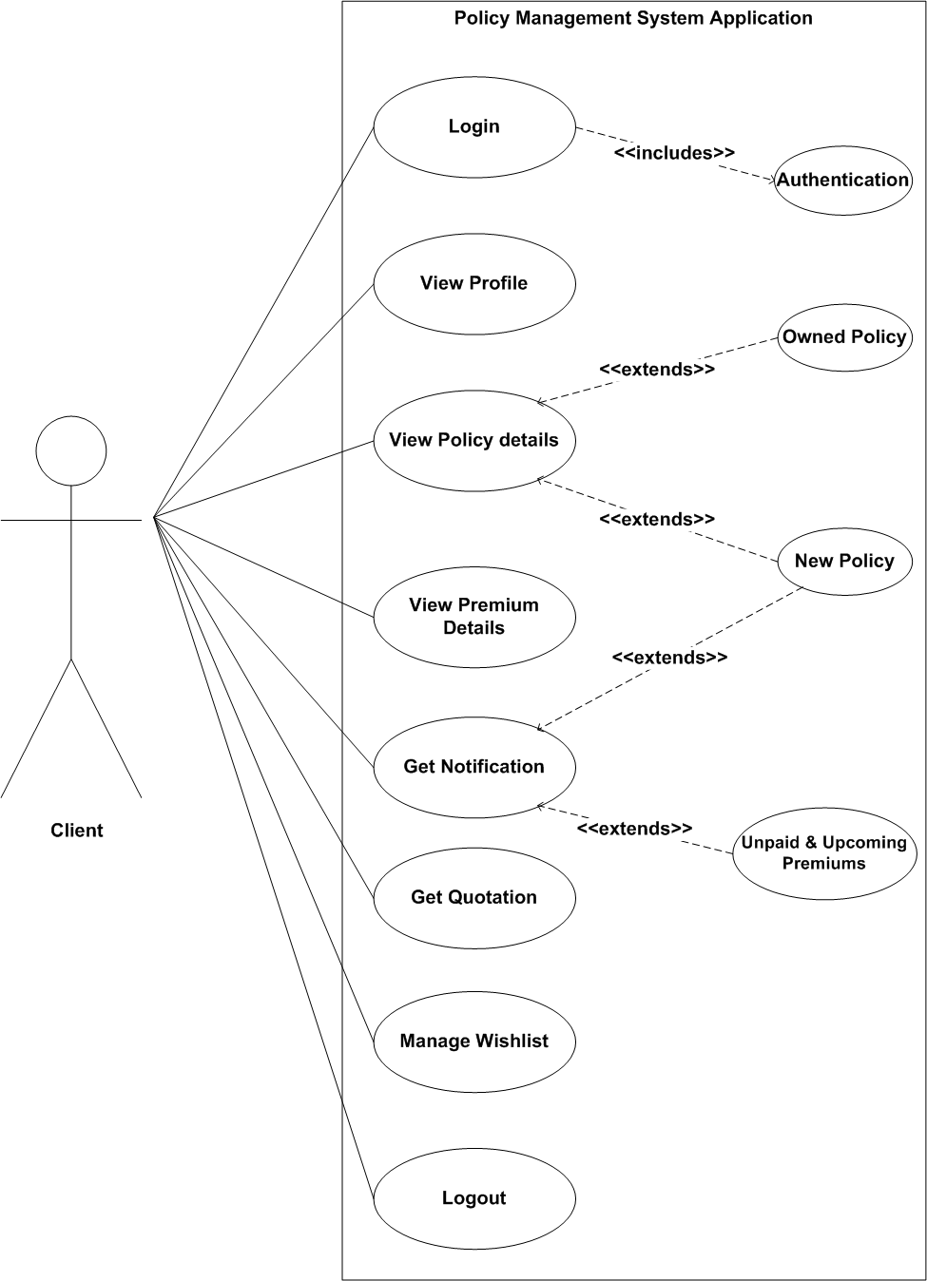

SR. NO.4.2 CLASS DIAGRAM

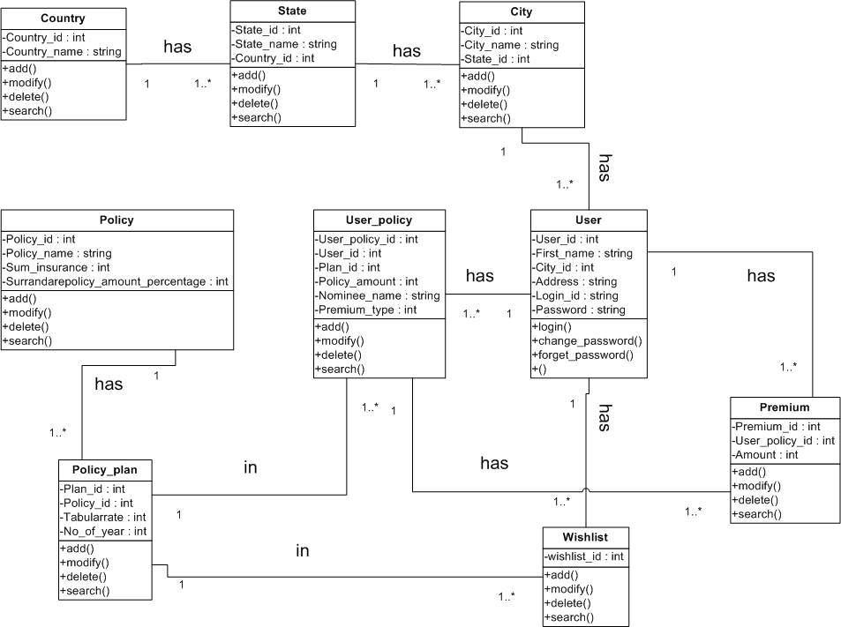

SR. NO.4.3 ACTIVITY DIAGRAM

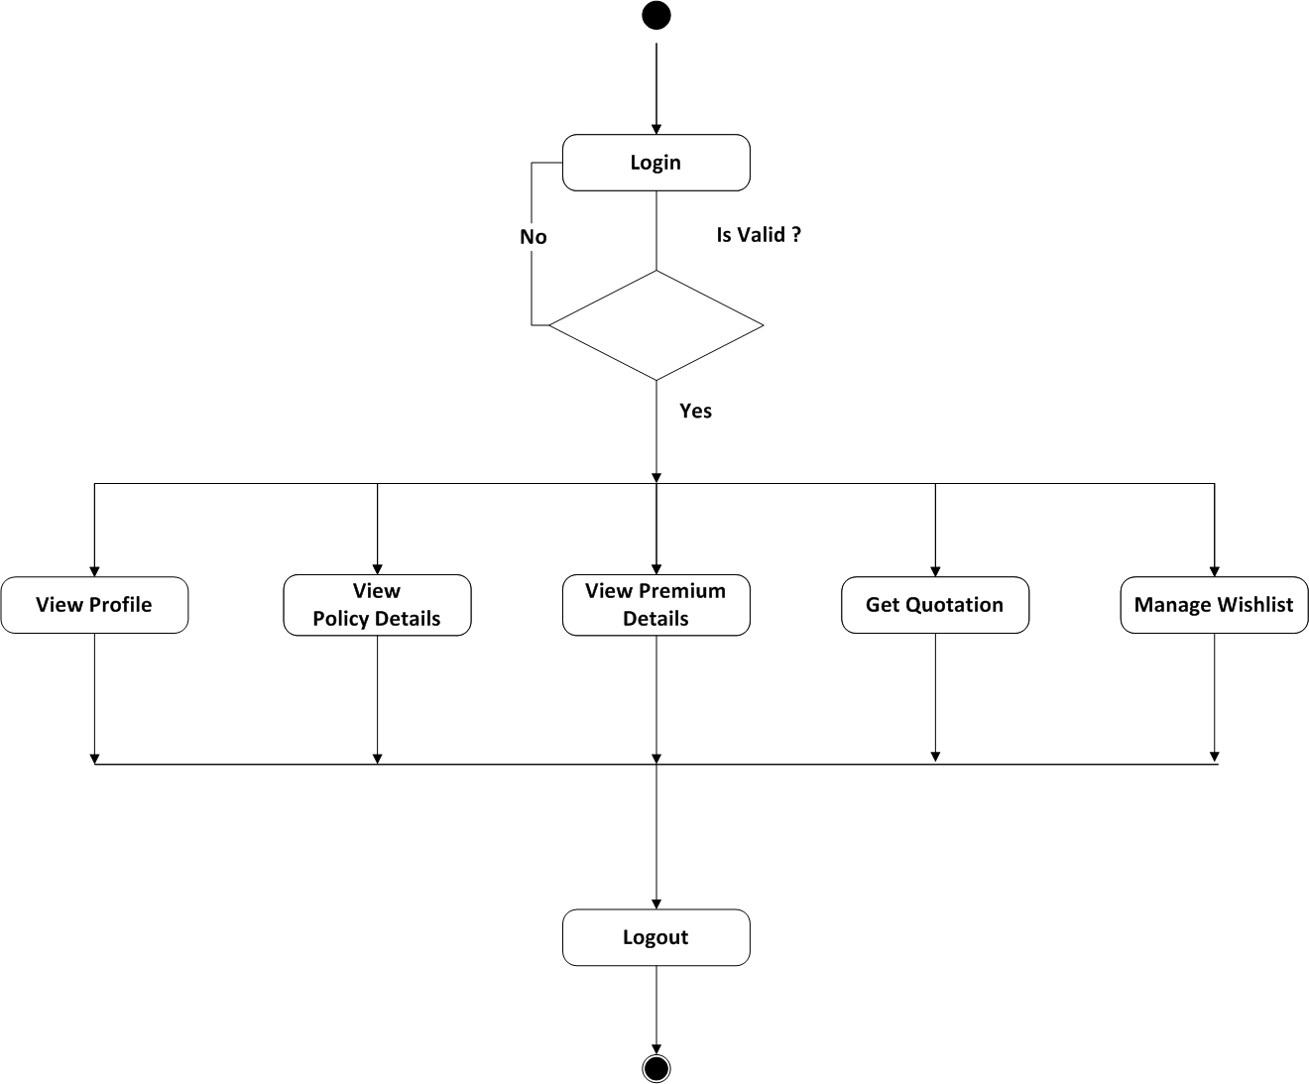

SR. NO.4.4 STATECHART DIAGRAM

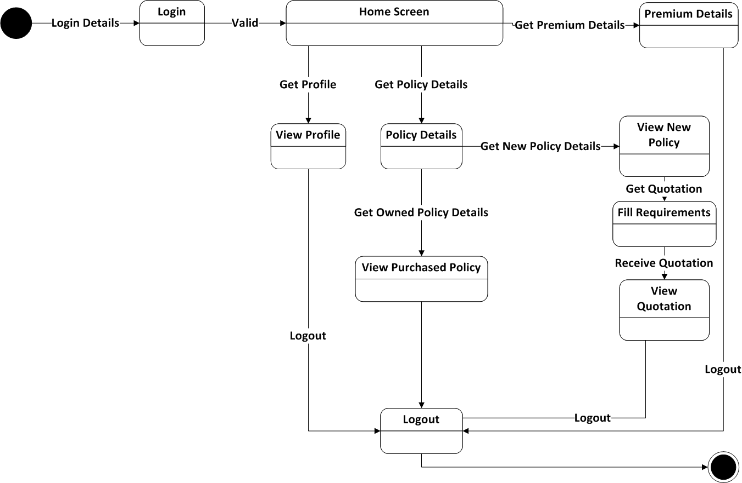

SR. NO.4.5 SEQUENCE DIAGRAM

**SEQUENCE DIAGRAM FOR LOGIN**

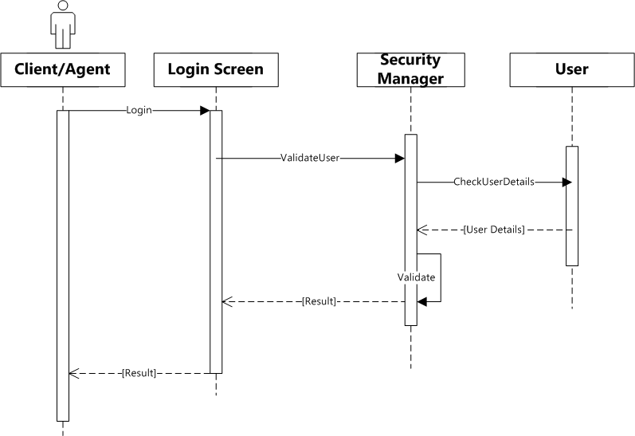

SR. NO.4.5 SEQUENCE DIAGRAM

**SEQUENCE DIAGRAM FOR POLICY**

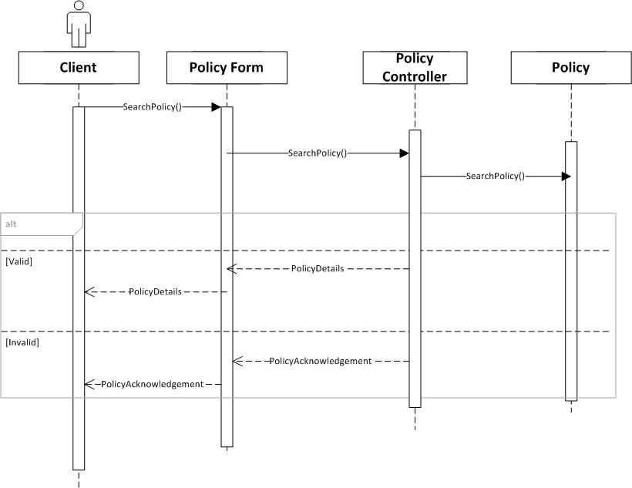

SR. NO.4.5 SEQUENCE DIAGRAM

**SEQUENCE DIAGRAM FOR PREMIUM**

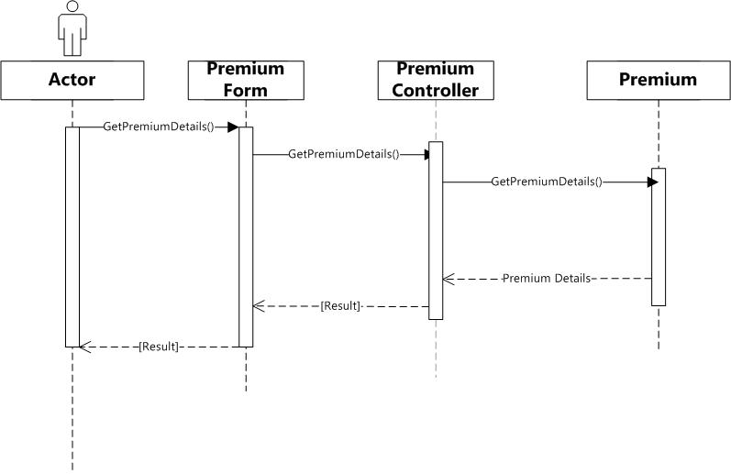

SR. NO.4.5 SEQUENCE DIAGRAM

**SEQUENCE DIAGRAM FOR QUATATION**

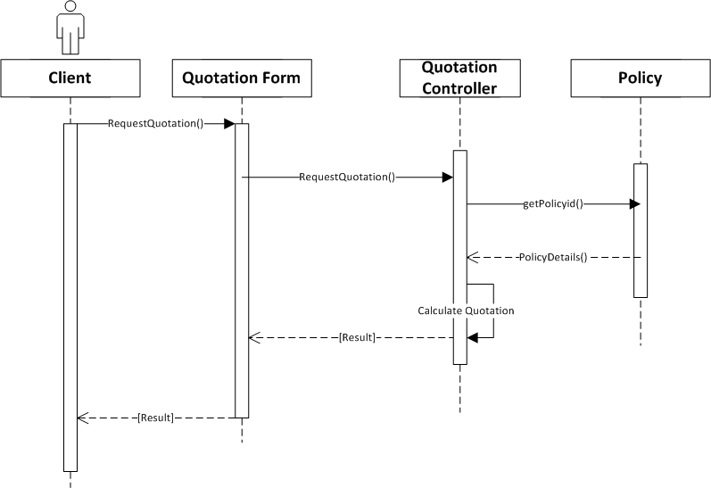SR. NO.4.5 SEQUENCE DIAGRA

**SEQUENCE DIAGRAM FOR WISHLIST**

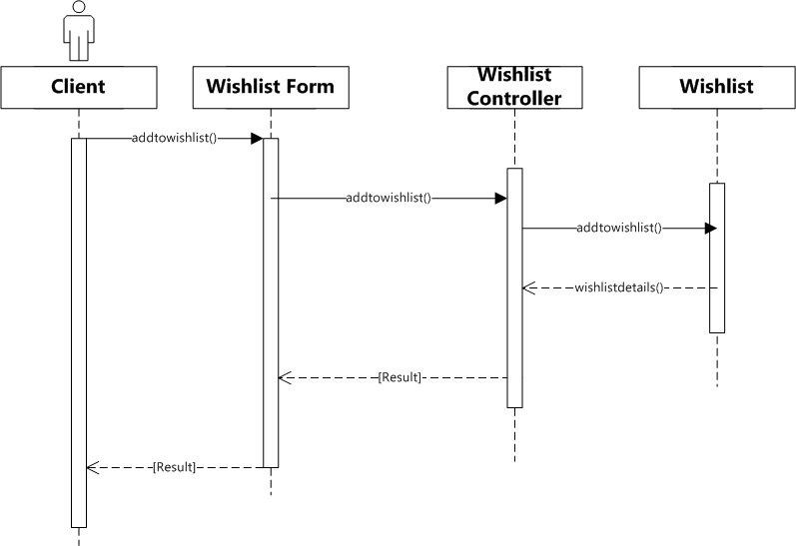

SR. NO.5.1 CONTEXT LEVEL DIAGRAM

**CONTEXT LEVEL DIAGRAM**

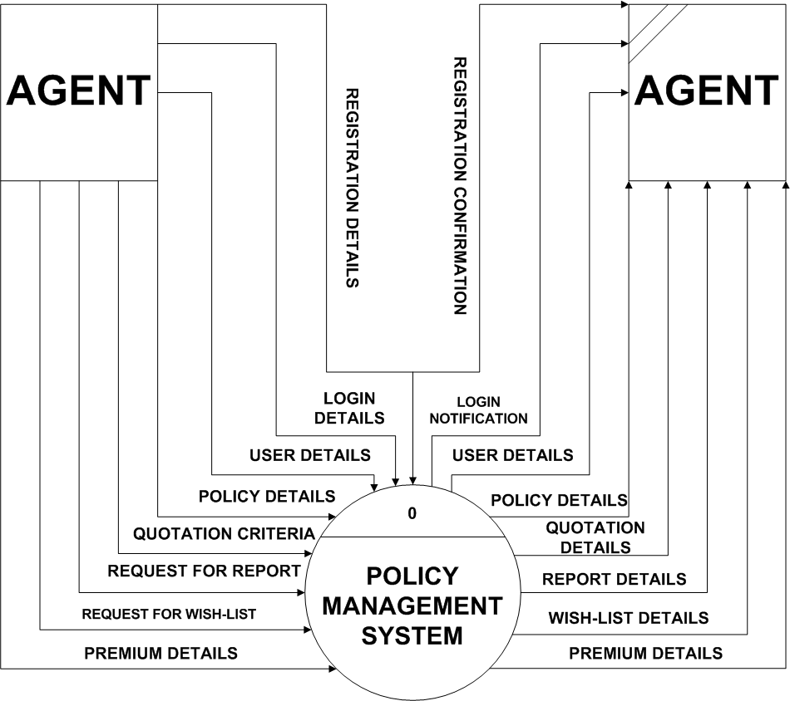

SR. NO.5.2 FIRST LEVEL DIAGRAM

**First Level Diagram**

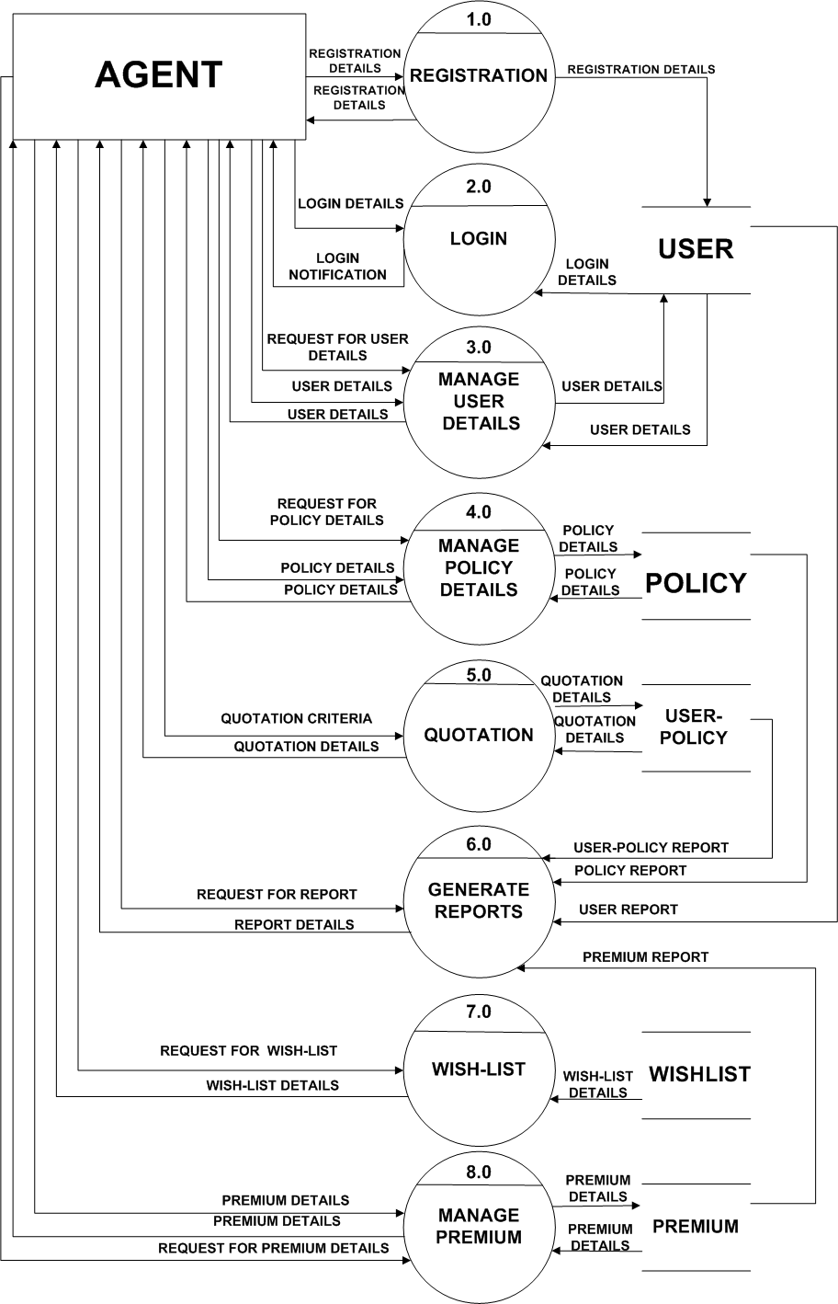

SR. NO. 5.3 SECOND LEVEL DIAGRAM

**Second Level For Login Process**

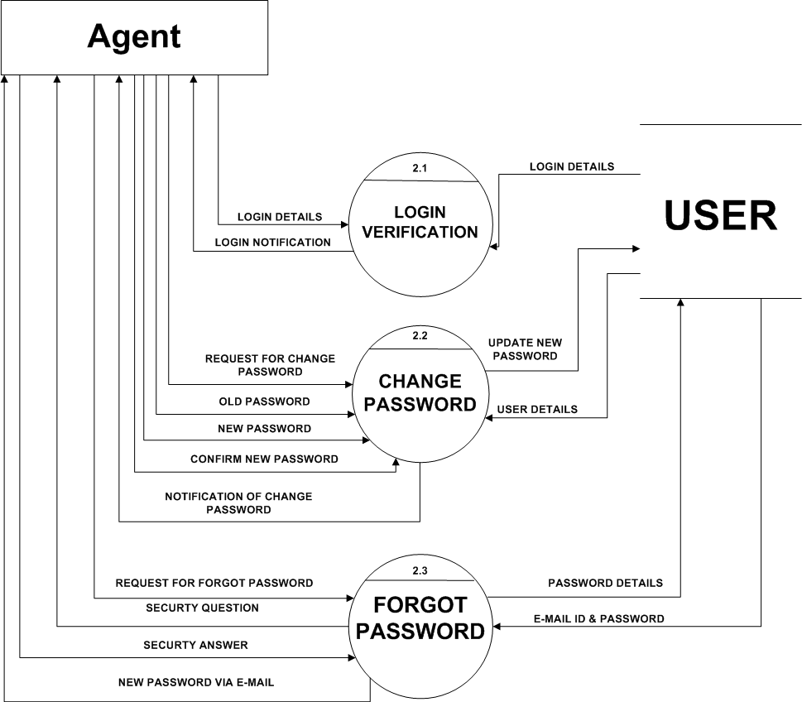

SR. NO. 5.3 SECOND LEVEL DIAGRAM

**Second Level For Manage User details**

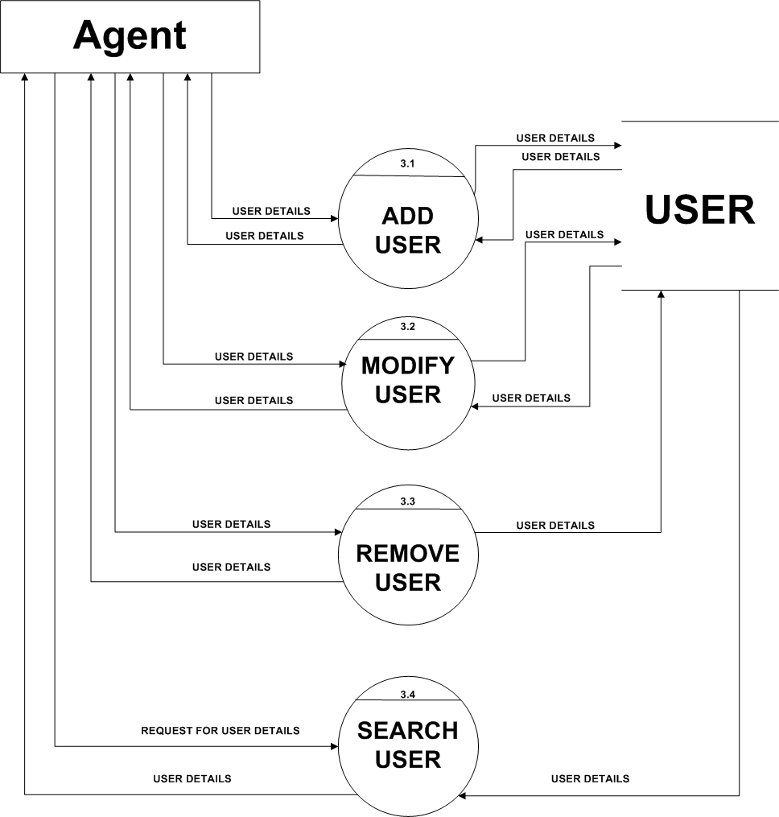

SR. NO. 5.3 SECOND LEVEL DIAGRAM

**Second Level For Manage Policy details**

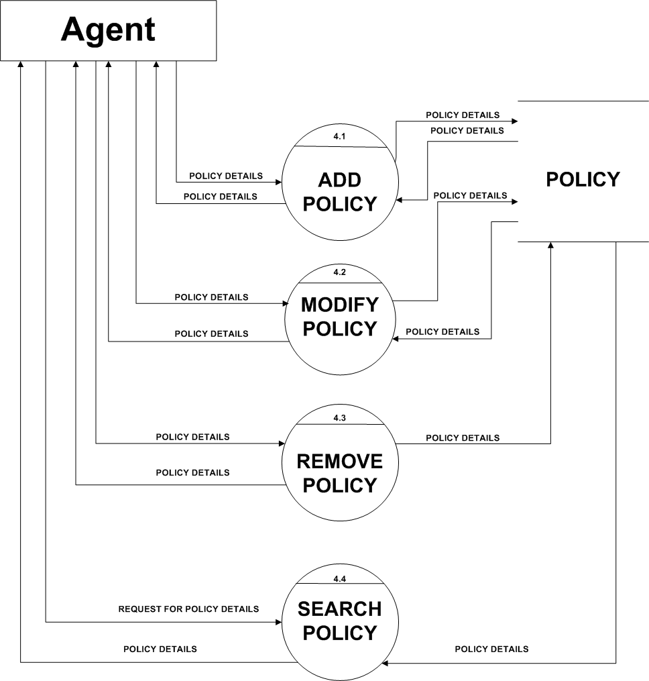

SR. NO. 5.3 SECOND LEVEL DIAGRAM

**Second Level For Manage Premium**

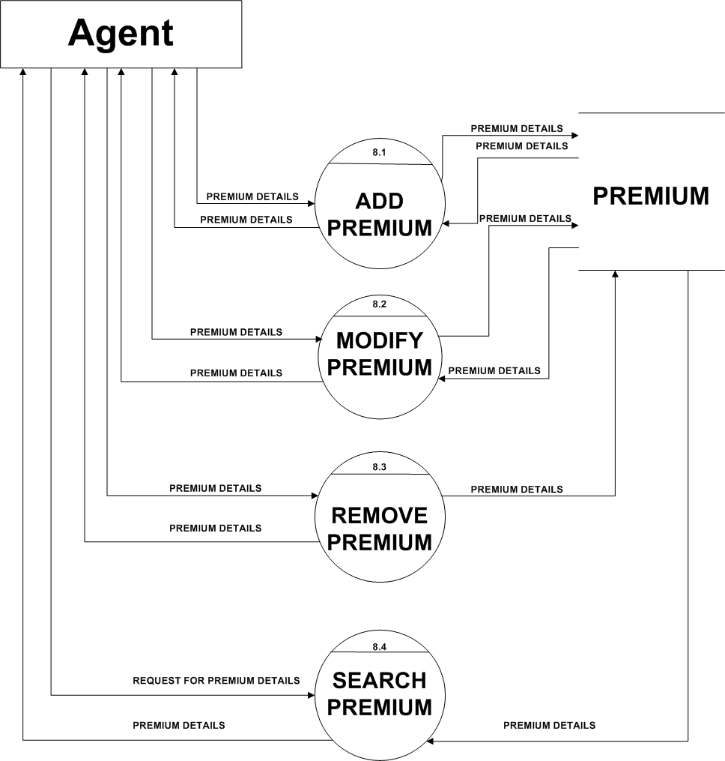

SR. NO. 6 DATA DICTIONARY

1.) Table Name: -**COUNTRY_TABLE**

Table Description: - **It stores country names and assign unique id to each country.**

|  |  |  |  |  |
| --- | --- | --- | --- | --- |
| **FIELD_NAME** | **DATA TYPE** | **SIZE** | **CONSTRAINTS** | **DESCRIPTION** |
| **Country_id** | TINYINT | 3 | **PRIMARY KEY** | IT WILL ASSIGN UNIQUE ID TO EACH COUNTRY AND STORE AS COUNTRY_ID. |
| Country_name | VARCHAR | 50 | NOT NULL | IT WILL STORE THE COUNTRY NAME. |

SR. NO. 6 DATA DICTIONARY

2.) Table Name: -**STATE_TABLE**

Table Description: - **It stores state names and assign unique id to each state.**

|  |  |  |  |  |
| --- | --- | --- | --- | --- |
| **FIELD_NAME** | **DATA TYPE** | **SIZE** | **CONSTRAINTS** | **DESCRIPTION** |
| **State_id** | TINYINT | 3 | **PRIMARY KEY** | IT WILL ASSIGN UNIQUE ID TO EACH STATE AND STORE AS STATE_ID. |
| State_name | VARCHAR | 50 | NOT NULL | IT WILL STORE THE STATE NAMES. |
| Country_id | TINYINT | 3 | FOREIGN KEY | IT IS THE PRIMARY KEY OF COUNTRY TABLE.IT IS THE FOREIGN KEY IN THIS TABLE AND CREATES A LINK BETWEEN COUNTRY TABLE AND STATE TABLE. |

SR. NO. 6 DATA DICTIONARY

3.) Table Name: -**CITY_TABLE**

Table Description: - **It stores city names and assign unique id to each city.**

|  |  |  |  |  |
| --- | --- | --- | --- | --- |
| **FIELD_NAME** | **DATA TYPE** | **SIZE** | **CONSTRAINTS** | **DESCRIPTION** |
| **City_id** | TINYINT | 3 | **PRIMARY KEY** | IT WILL ASSIGN UNIQUE ID TO EACH CITY AND STORE AS CITY_ID. |
| City_name | VARCHAR | 50 | NOT NULL | IT WILL STORE THE CITY NAMES. |
| State_id | TINYINT | 3 | FOREIGN KEY | IT IS THE PRIMARY KEY OF STATE TABLE. IT IS THE FOREIGN KEY IN THIS TABLE AND CREATES A LINK BETWEEN STATE TABLE AND CITY TABLE. |

SR. NO. 6 DATA DICTIONARY

4.) Table Name: -**USER_TABLE**

Table Description: - **It stores all the required details of each client.**

|  |  |  |  |  |
| --- | --- | --- | --- | --- |
| **FIELD_NAME** | **DATA TYPE** | **SIZE** | **CONSTRAINTS** | **DESCRIPTION** |
| **User_id** | INT | 10 | **PRIMARY KEY** | IT WILL ASSIGN UNIQUE ID TO EACH USER AND STORE AS USER_ID. |
| First_name | VARCHAR | 50 | NOT NULL | IT WILL STORE THE FIRST NAME OF EACH USER. |
| Middle_name | VARCHAR | 50 | NOT NULL | IT WILL STORE MIDDLE NAME OF EACH USER. |
| Last_name | VARCHAR | 50 | NOT NULL | IT WILL STORE THE LAST NAME OF EACH USER. |
| Address | VARCHAR | 255 | NOT NULL | IT WILL STORE THE ADDRESS OF EACH USER. |
| City_id | TINYINT | 3 | FOREIGN KEY | IT IS A PRIMARY KEY OF CITY TABLE.IT WILL CREATE A LINK BETWEEN USER TABLE AND CITY TABLE.IT WILL BECOME THE CHILD TABLE OF USER TABLE. |
| Login_id | VARCHAR | 30 | NOT NULL | IT WILL STORE THE LOGIN_ID OF EACH USER. |
| Password | VARCHAR | 20 | NOT NULL | IT WILL STORE THE PASSWORD OF EACH USER. |
| Anniversary_date | DATE |  |  | IT WILL STORE THE ANNIVERSARY DATE OF USER IF THE USER IS MARRIED.THUS,IT IS OPTIONAL. |
| Id_proof | VARCHAR | 100 | NOT NULL | IT WILL STORE IMAGE FILE OF EITHER OF THE GOVERNMENT GENERATED ID PROOFS FOR EG :  DRIVING LICENCE , PASSPORT , ELECTION CARD , AADHAR CARD , PAN CARD. |
| Address_proof | VARCHAR | 100 | NOT NULL | IT WILL STORE IMAGE FILE OF EITHER OF THE ADDRESS PROOFS FOR EG :  ELECTRICITY BILL , TELEPHONE BILL , WATER BILL. |
| Office_address | VARCHAR | 255 |  | IT WILL STORE THE OFFICE ADDRESS OF EACH USER. IT IS OPTIONAL. |
| User_type | TINYINT | 1 | NOT NULL | IT STORES IF THE USER IS A CLIENT OR AN ADMIN .  0 – CLIENT  1 - ADMIN |
| Premium_payment_mode | TINYINT | 1 | NOT NULL | IT STORES IF THE CLIENT WILL PAY MONEY ONLINE OR TO THE AGENT  0 – ONLINE  1 - MANUAL |
| Registration_date | DATE |  | NOT NULL | IT WILL STORE THE REGISTRATION DATE OF EACH USER. |

SR. NO. 6 DATA DICTIONARY

5.) Table Name: -**POLICY_TABLE**

Table Description: - **It stores details of each policy.**

|  |  |  |  |  |
| --- | --- | --- | --- | --- |
| **FIELD_NAME** | **DATA TYPE** | **SIZE** | **CONSTRAINTS** | **DESCRIPTION** |
| **Policy_id** | INT | 5 | **PRIMARY KEY** | IT WILL ASSIGN AN UNIQUE ID TO EACH POLICY. |
| Policy_name | VARCHAR | 50 | NOT NULL | IT WILL STORE THE NAMES OF EACH POLICY. |
| Policy_number | VARCHAR | 10 | NOT NULL | IT WILL STORE THE POLICY NUMBER OF EACH POLICY. |
| Sum_insurance | INT | 8 | NOT NULL | IT STORES THE MINIMUM AMOUNT OF THE POLICY . |
| Surrandarepolicy_amount_percentage | TINYINT | 3 | NOT NULL | IT STORES THE PERCENTAGE AMOUNT A USER CAN GET WHEN HE DISCONTINUES HIS/HER POLICY.. |
| Min_age | TINYINT | 2 | NOT NULL | IT WILL STORE THE MINIMUM AGE REQUIRED FOR THIS POLICY. |
| Max_age | TINYINT | 2 | NOT NULL | IT WILL STORE THE MAXIMUM AGE REQUIRED FOR THIS POLICY. |

SR. NO. 6 DATA DICTIONARY

6.) Table Name: -**POLICY_PLAN_TABLE**

Table Description: - **It stores plans of each policy.**

|  |  |  |  |  |
| --- | --- | --- | --- | --- |
| **FIELD_NAME** | **DATA TYPE** | **SIZE** | **CONSTRAINTS** | **DESCRIPTION** |
| **Plan_id** | TINYINT | 2 | **PRIMARY KEY** | IT WILL STORE THE PLAN ID OF EACH POLICY PLAN. |
| Policy_id | INT | 5 | FOREIGN KEY | IT IS A PRIMARY KEY OF POLICY TABLE.IT WILL CREATE A LINK BETWEEN POLICY TABLE AND POLICY_PLAN TABLE. |
| Tabularrate | TINYINT | 3 | NOT NULL | IT IS A RATE DEFINED BY THE POLICY MAKERS FOR CALCULATING THE PREMIUM. |
| S_A_Rebet_two_to_five_lac | TINYINT | 2 | NOT NULL | IT STORES A DISCOUNT VALUE A USER CAN GET WHEN HIS POLICY IS BETWEEN 2 TO 5 LAKHS.THIS DISCOUNT IS GIVEN ON TABULARRATE. |
| S_A_Rebet_above_five_lac | TINYINT | 2 | NOT NULL | IT STORES A DISCOUNT VALUE A USER CAN GET WHEN HIS POLICY IS ABOVE 5 LAKHS. THIS DISCOUNT IS GIVEN ON TABULARRATE. |
| Mode_Rebet_sixmonth_premium | TINYINT | 2 | NOT NULL | IT STORES A DISCOUNT VALUE A USER CAN GET WHEN HE PAYS PREMIUM EVERY HALF YEARLY.THIS DISCOUNT IS GIVEN ON TABULARRATE. |
| Mode_Rebet_oneyear_premium | TINYINT | 2 | NOT NULL | IT STORES A DISCOUNT VALUE A USER CAN GET WHEN HE PAYS PREMIUM EVERY YEARLY THIS DISCOUNT IS GIVEN ON TABULARRATE. |
| No_of_year | TINYINT | 2 | NOT NULL | IT STORES THE NUMBER OF YEARS FOR THE POLICY. |

SR. NO. 6 DATA DICTIONARY

7.) Table Name: -**USER_POLICY_TABLE**

Table Description: - **It stores details of user who have purchased a policy.**

|  |  |  |  |  |
| --- | --- | --- | --- | --- |
| **FIELD_NAME** | **DATA TYPE** | **SIZE** | **CONSTRAINTS** | **DESCRIPTION** |
| **User_policy_id** | TINYINT | 2 | **PRIMARY KEY** | ASSIGN UNIQUE ID TO EACH POLICY PURCHASED BY THE USER |
| User_id | INT | 10 | FOREIGN KEY | IT IS A PRIMARY KEY OF USER TABLE.IT WILL CREATE A LINK BETWEEN CLIENT_POLICY TABLE AND USER TABLE. |
| Plan_id | TINYINT | 2 | FOREIGN KEY | IT IS A PRIMARY KEY OF POLICY_PLAN TABLE.IT WILL CREATE A LINK BETWEEN PLOICY_PLAN TABLE AND CLIENT_POLICY TABLE. |
| Policy_purchase_date | DATE |  | NOT NULL | IT WILL STORE THE DATE OF WHEN THE POLICY WAS PURCHASED. |
| Policy_amount | INT | 10 | NOT NULL | IT WILL STORE THE TOTAL AMOUNT OF THE POLICY. |
| Nominee_name | VARCHAR | 100 | NOT NULL | IT WILL STORE THE NOMINEE NAME GIVEN BY THE USER. |
| Relation_type | VARCHAR | 30 | NOT NULL | STORE THE KIND OF RELATION BETWEEN THE NOMINEE AND THE USER. |
| Premium_type | TINYINT | 1 | NOT NULL | STORE THE TYPE IN WHICH THE PREMIUM IS PAID TO THE AGENT.  0 – YEARLY,1 – HALF_YEARLY,2 – 3 MONTHLY,3 – MONTHLY |
| Policy_status | TINYINT | 1 | NOT NULL | STORES THE STATUS OF THE POLICY.  0 – LAPSED  1 – IT STILL EXISTS |

SR. NO. 6 DATA DICTIONARY

8.) Table Name: -**PRMIUM_TABLE**

Table Description: - **It stores details which are related to premiums.**

|  |  |  |  |  |
| --- | --- | --- | --- | --- |
| **FIELD_NAME** | **DATA TYPE** | **SIZE** | **CONSTRAINTS** | **DESCRIPTION** |
| **Premium_id** | TINYINT | 2 | **PRIMARY KEY** | ASSIGN UNIQUE ID TO EACH PREMIUM. |
| User_policy_id | TINYINT | 2 | FOREIGN KEY | IT IS A PRIMARY KEY OF USER_POLICY TABLE .IT IS A CHILD TABLE OF PREMIUM TABLE. IT CREATES A LINK BETWEEN PREMIUM TABLE AND CLIENT_POLICY TABLE. |
| Payment_date | DATE |  | NOT NULL | IT WILL STORE THE DATE ON WHICH PREMIUM WAS PAID BY THE CLIENT. |
| Amount | INT | 8 | NOT NULL | STORES THE AMOUNT THAT IS TO BE PAID BY THE CLIENT. |
| Check_Number | VARCHAR | 14 |  | STORES THE CHECK NUMBER IF THE PREMIUM PAYMENT IS DONE BY CHEQUE. |
| Payment_mode | TINYINT | 1 | NOT NULL | STORES THE TYPE OF MODE THROUGH WHICH THE CLIENT DOES THE PAYMENT.  0 – CASH  1 – CHEQUE. |

SR. NO. 6 DATA DICTIONARY

9.)Table Name: -**TAX_TABLE**

Table Description: - **It stores details of various taxes which are use in calculations.**

|  |  |  |  |  |
| --- | --- | --- | --- | --- |
| **FIELD_NAME** | **DATA TYPE** | **SIZE** | **CONSTRAINTS** | **DESCRIPTION** |
| **Tax_id** | TINYINT | 2 | **PRIMARY KEY** | IT WILL ASSIGN UNIQUE ID TO DIFFERENT TYPES OF TAX. |
| Tax_name | VARCHAR | 50 | NOT NULL | IT WILL STORE THE TAX NAMES. |
| Tax_percentage | TINYINT | 2 | NOT NULL | IT WILL STORE THE PERCENTAGE VALUE OF EACH TAX, USED IN EVALUATION OF PREMIUM. |

SR. NO. 6 DATA DICTIONARY

10.) Table Name: -**BANK_TABLE**

Table Description: - **It stores details of banks and account_no of clients.**

|  |  |  |  |  |
| --- | --- | --- | --- | --- |
| **FIELD_NAME** | **DATA TYPE** | **SIZE** | **CONSTRAINTS** | **DESCRIPTION** |
| **Bank_id** | TINYINT | 2 | **PRIMARY KEY** | IT WILL ASSIGN UNIQUE ID TO EACH BANK. |
| Bank_name | VARCHAR | 20 | NOT NULL | IT WILL STORE BANK NAMES. |
| Account_no | VARCHAR | 20 | NOT NULL,UNIQUE | IT WILL STORE ACCOUNT NUMBER OF EACH USER. |

SR. NO. 6 DATA DICTIONARY

11.) Table Name: -**WISHLIST_TABLE**

Table Description: - **It stores details of client’s wishlish.**

|  |  |  |  |  |
| --- | --- | --- | --- | --- |
| **FIELD_NAME** | **DATA TYPE** | **SIZE** | **CONSTRAINTS** | **DESCRIPTION** |
| **Wishlist_id** | TINYINT | 3 | **PRIMARY KEY** | IT WILL ASSIGN UNIQUE ID TO EACH WISHLIST AND STORE AS WISHLIST_ID. |
| User_id | INT | 10 | FOREIGN KEY | IT IS A PRIMARY KEY OF USER TABLE.IT WILL CREATE A LINK BETWEEN WISHLIST TABLE AND USER TABLE. |
| Plan_id | TINYINT | 2 | FOREIGN KEY | IT IS THE PRIMARY KEY OF POLICY_PLAN TABLE.  IT IS THE FOREIGN KEY IN THIS TABLE AND CREATES A LINK BETWEEN POLICY_PLAN TABLE AND USER_WISHLIST TABLE |

SR. NO. 7 BIBLIOGRAPHY

**Analysis is done with this reference book:-**

* Magnifying – Arpita Gopal and Netra Patil
* System Analysis and Design Methods – Gary B. Shelly, Thomas J Cashman, Harry J. Rosenblatt

**Analysis is done with these reference websites:-**

* [**http://www.w3schools.com**](http://www.w3schools.com)
* [**http://www.objectmentor.com**](http://www.objectmentor.com)
* [**http://www.tutorialspoint.com**](http://www.tutorialspoint.com)
* [**http://www.uml-diagram.org**](http://www.uml-diagram.org)
* **http://www.w3computing.com**